An Efficient Wireless Power Transfer System for EV Charging Using High-Frequency Resonant Inverter
K. Praveena¹, Dummu Gandhi², Ponnamanda Khyathi³, Pilla Chandra Mouli⁴, Mannena Hari Sankar⁵
¹Associate Professor, Department of Electrical and Electronics Engineering, Avanthi Institute of Engineering and Technology, Andhra Pradesh, India.
²Department of Electrical and Electronics Engineering, Avanthi Institute of Engineering and Technology, Andhra Pradesh, India.
³Department of Electrical and Electronics Engineering, Avanthi Institute of Engineering and Technology, Andhra Pradesh, India.
⁴Department of Electrical and Electronics Engineering, Avanthi Institute of Engineering and Technology, Andhra Pradesh, India.
⁵Department of Electrical and Electronics Engineering, Avanthi Institute of Engineering and Technology, Andhra Pradesh, India.
veenaphilip2006@gmail.com
ABSTRACT: In the world, Electric Vehicles (EVs) are a promising technology for developing a sustainable transportation sector because of their extremely low to zero carbon emissions, low noise levels, high efficiency, and flexibility in grid operation and integration. Thus, the number of EVs in use is growing annually. In recent years, Wireless Power Transfer (WPT) systems have been utilized as EV battery chargers. Designing effective power electronic converters enables the WPT system to operate at high frequencies, which is a typical feature for transmitting large amounts of power over longer distances. Therefore, this paper proposes a WPT system based on an efficient high-frequency inverter for an EV charging system. A high-frequency inverter decreases the size and resistance of passive components like inductors and is utilized for operating more effectively than a low frequency. The primary function of an isolation transformer is to provide electrical isolation between the high-voltage battery and the low-voltage systems. Finally, interleaved synchronous rectifiers are used to improve efficiency, reduce current ripple, and enhance charging power and energy received for load application. Further, a PI controller helps maintain stability and optimal performance. The MATLAB/Simulink simulation indicates that the proposed system has improved switching losses, reactive power compensation, and the highest efficiency of 98%.
Keywords: High frequency inverter, EV, Isolation transformer, Interleaved Synchronous Rectifiers.

1. Introduction
Vehicles are presently recognized to be among the most efficient modes of transportation. These vehicles use fossil fuels, so air pollution is increased day by day. Hence, EVs are introduced, and using renewable energy to generate electricity, just transferring emissions from vehicles to power plants [1]. The benefits of renewable energy include being a limitless, low-maintenance, and commercially viable energy source. It has also gained favour as a green technology in recent years. Innovations in clean energy are currently changing the modern world to offer better practices, including reduced fuel prices, carbon emissions, and a clean atmosphere [2-3]. This renewable energy is used as a stand-alone source or linked to the grid system. The creation of environmentally friendly and commercially viable alternative sources of electric power generation is urgently needed. In one of the most important components, inverters are used [4]. Many inverters are used for storing and charging purposes, such as DC-DC inverters, bidirectional inverters, and Voltage Source Inverters (VSIs), tc. DC-DC inverters are used to change the voltage of DC to the load. Further, it controls the frequency and amplitude of the AC signal to regulate the motor’s speed and torque. Bidirectional inverters allow EVs to act as energy storage units for the grid, helping to balance supply and demand and supporting the integration of RES. VSI is the standard inverter used in most EVs today because of its simplicity, reliability, and effectiveness. However, at high switching frequencies, VSI is experiencing losses that affect performance, though modern materials are reducing this [5].
The majority of inverters need sophisticated control techniques to be stable and effective, particularly in variable and renewable applications. Because of this intricacy, more complex control circuits or microcontrollers are required, it raises the cost and complexity of the design. Previous inverters have several disadvantages that are carefully considered during the design and selection process since it impacts performance, cost, and reliability. Nevertheless, these inverters use high-order resonant structures that are highly complicated and have a large number of energy storage components and/or modes. So, the next level inverters are required for the EV charging system [6-7]. Charging these vehicles with WPT has been provided as a way to achieve an ecologically sustainable future transportation system because of the operational and environmental benefits. As a result, WPT systems are used with devices with low power ratings [9-10]. Hence this work is a WPT system based on an efficient high-frequency inverter that is used for EV charging. As a result, it has better accuracy, produces more active power, and is more efficient. Consequently, the fundamental intention of the proposed system is represented as follows:
- To maximize the amount of energy recovered and improve the vehicle’s overall energy efficiency, a high-frequency inverter is used.
- To reduce the component failure and handle the dynamic conditions, an interleaved synchronous rectifier is employed.
- To protect low-voltage systems from high-voltage spikes or transients that occur in the high-voltage circuits, isolation transformers are utilized.
- To improve efficiency and enhance performance, an interleaved synchronous rectifier is used.
In the EV system, this paper proposes an efficient high-frequency resonant inverter used for the charging system. Section II analyzes recent works. Section III outlines the methodologies of the proposed technique. Section IV provides a performance analysis of the result. Section V also provides the conclusion part.

2. Recent Works
Allamsetty Hema Chander et al (2023) [11] have proposed a modular transformer less grid-connected photovoltaic multilevel inverter that realizes the individual maximum power point (MPP) of each module under different operating scenarios in EV purposes. It accomplishes dynamic correction for error and zero static error control. Additionally, it improves the system's overall control performance. As the load increases, there are slight, temporary disruptions in the frequency. The output voltage of solar panels is not high enough to satisfy grid voltage class standards, hence a boost DC/DC converter is required.
Debabrata Mazumdar et al (2024) [12] have developed Genetic Algorithm (GAO) optimized sliding mode based reconfigurable step size Pb&O controller for grid integrated EV charging station. The boost converter's incremental conductance algorithm-based functioning guarantees that the PV produces most power possible. In order to achieve the MPP with minimal oscillation, it improves the tracking performance of the controller. It is crucial for improving the frequency stability of the grid-connected solar power generation system in the case of a minor disturbance. Complex power systems are generated, and parameters are required in inverters and machine settings.
Xupeng Fang et al (2024) [13] have presented boost-zeta DC/DC converters utilized for applications in the field of EV charging systems. This converter is a reasonably priced retrofit for uses of grid-integrated battery charging. Despite the loading imbalances between phases and arms, the three-phase grid current must remain balanced and sinusoidal. This method is more computationally complex because it requires additional variables for frequency synchronization and reactive power management.
Mohammad Ali Hosseinzadeh et al (2024) [14] have developed a generalized topology for multisource inverters for minimizing power losses in EVs. It offers simplicity, high performance, and low harmonic content. However, it indicates some restrictions due to the wide range of electric machine (EM) performance and the need for high power. Further, some parameters are required for electricity stored during charging and discharging conditions. However, the distortions generated by voltage distortions have an impact and also lengthen the duration of synchronism loss.
Erdem Gümrükcü et al (2022) [15] have proposed a grid interface based on Modular Multilevel Converter (MMC) for the charging demand in EVCSs. Its conversion efficiency is better because it has lower switching damages. Although the output power increases as the duty period gets extended, it falls as the duty period is decreased. To meet the required voltage stability criterion, a second harmonic current must be injected when the intra-arm imbalances are substantial.
3. Proposed Work Explanation
A WPT-based high-frequency inverter is proposed in this work to achieve high efficiency for EV charging applications. Figure 1: indicates the block diagram illustration of the proposed work.

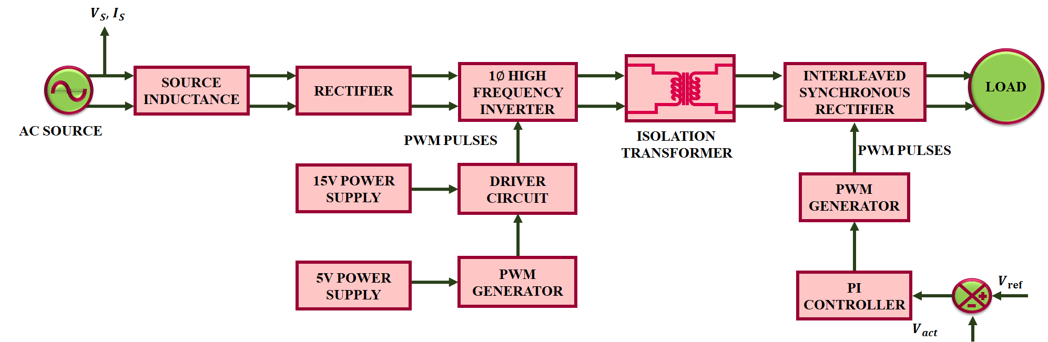
Figure 1: Block Diagram for Proposed Work

First, the AC supply is applied for a source inductance, which lessens abrupt variations and reduces the current flow. The AC supply is then converted to DC using a single-phase rectifier. Conversely, the 1∅ high-frequency inverter receives the 15V and 5V power supplies. Following the rectifier's output, one high-frequency inverter is accepted to receive sinusoidal PWM pulses. The PWM generator, on the other hand, produces the pulse for one PWM rectifier. Then, in order to function at high frequencies, an inverter converts DC electricity to high-frequency AC power. After that, the isolation transformer receives the output, which transfers electricity and manages high voltage differentials securely while offering electrical isolation and safety between two circuits. A PI controller controls the voltage and current that adjusts the system to achieve the desired speed or torque. PWM pulses and transferred power are then passed to the initial stage of a synchronous rectifier, which aids in increasing efficiency and lowering heat dissipation and energy loss during the AC to DC conversion process. Lastly, a suitable and effective output power supply for the load application is obtained.

3.1 Single Phase High-Frequency Inverter
A single phase high-frequency inverter in an EV is an essential component used to convert the DC power from the vehicle’s battery to AC power, which is used by certain vehicle systems. Reactive power compensation and harmonic control are achieved by converting the DC voltage output into high-frequency AC voltage. The power switches for driving signal modification are defined by the four parameters $Q_{1}$, $Q_{2}$, $Q_{3}$and $Q_{4}$. Since both switches are turned on at the same time, $Q_{1}$, $Q_{2}$, $Q_{3}$and $Q_{4}$ are all turned on at the same time. In this working mode, the voltage of the load is reversed. The DC voltage is transformed into a high-frequency AC voltage by adjusting the switch tube's on-time. The AC output voltage of the high-frequency inverter is determined by the PWM modulation technique used. Figure 2: depicts the high-frequency inverter.
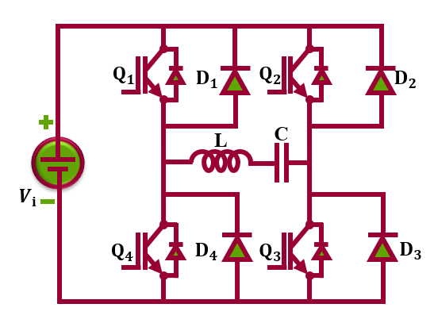
Figure 2: The High- Frequency Inverter
The output voltage $V_{out}\left(t\right)$ is expressed as,
$V_{out}\left(t\right)=V_{peak}\sin\left(ωt\right)$(1)
Where, $V_{peak}$​ is the peak output voltage, $ω$ is the angular frequency and $t$ is time.
The AC output power $P_{out}$ is expressed as,
$P_{out}=V_{rms}.I_{rms}$ (2)
Where, $V_{rms}$​ is the Root-Mean-Square (RMS) value of the output voltage and $I_{rms}$​ is the RMS value of the output current.
The output power is written as,
$P_{out}=\frac{V_{peak}}{\sqrt{2}}.\frac{I_{peak}}{\sqrt{2}}=\frac{V_{peak}.I_{peak}}{2}$ (3)
The efficiency of the high-frequency inverter is the ratio of output power to input power,
$η=\frac{P_{out}}{P_{in}}=\frac{V_{peak}.I_{peak}}{V_{in}.I_{in}}$(4)
This equation highlights how efficiently the inverter is converting DC power from the battery into AC power delivered to the load.
For a high-frequency inverter, the switching frequency $f_{s}$ is expressed as:
$f_{s}=\frac{1}{T_{s}}$ (5)
Where $T_{s}$​ is the switching period. Higher switching frequencies can reduce the size of passive components and improve efficiency.

3.2 Source Inductance
Source inductance refers to the inductance associated with the battery or the power supply system that provides energy to the EV. The waveforms of the input current and output voltage also undergo substantial changes. As a result, the output voltage drops together with the load current. Figure 3: presented the circuit diagram of source inductance.
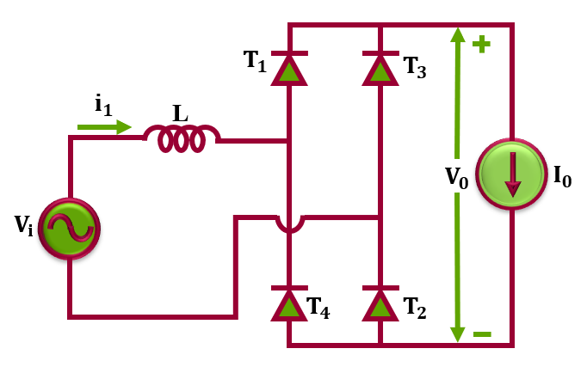
Figure 3: The Source Inductance
When $t = 0$, it is believed that the thyristors $T_{3}$ and $T_{4}$ are in conduction mode. Conversely, $T_{1}$ and $T_{2}$ spark when $ωt = α$. Commutation will take place at $T_{3}$ and $T_{4}$ in the absence of source inductance. Thyristors T$T_{1}$ and $T_{2}$ are turned on right away. As a result, the input polarity will instantly shift. Commutation and polarity shift cannot occur instantly when source inductance is present. All four thyristors will be conducting at some point. The overlap interval (μ) is a label given to this conducting interval. It is primarily caused by the battery’s internal resistance, the wiring from the battery to the power electronics, and any other conductive elements in the system.

3.3 PWM Rectifier
It is a power electrical device that uses active switching components to transform an AC voltage into a regulated DC voltage. The structural structure of the PWM rectifier is shown in Figure 4.
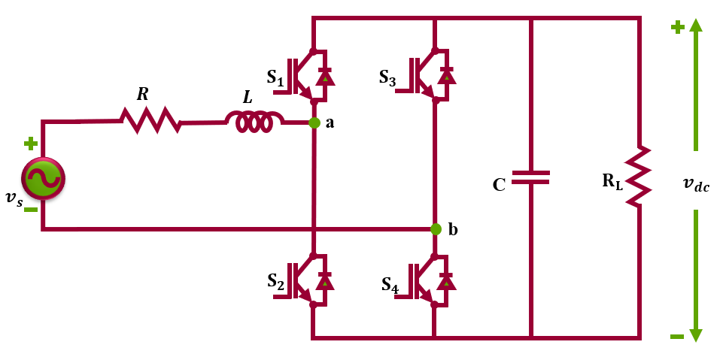
Figure 4: Block diagram of PWM rectifier.
The single-phase PWM rectifier is composed of four switches, a filter inductance, and a DC-link capacitor. L is the filter inductance, $s_{1}$ through $s_{4}$ are the four switches, with $s_{1}$ and $s_{2}$ designated as leg a, $s_{3}$ and $s_{4}$as leg b, $v_{dc}$ as the DC voltage, $v_{s}$ as the input AC voltage, $i_{s}$ as the input current, and C as the DC-link capacitor. The source phase's voltages are as follows:
$v_{s}={L\frac{{di}_{s}}{dt}+v}_{ab}$ (6)
Where, $v_{ab}$ is the input voltage of the rectifier.

3.4 Interleaved Synchronous Rectifier
One circuit architecture that increase efficiency is interleaved synchronous rectification, which is typically used in secondary side rectification circuits. In place of diodes, Metal-Oxide-Semiconductor Field-Effect Transistors (MOSFETs) are utilized for rectification. Figure 5: shows an interleaved synchronous rectifier.
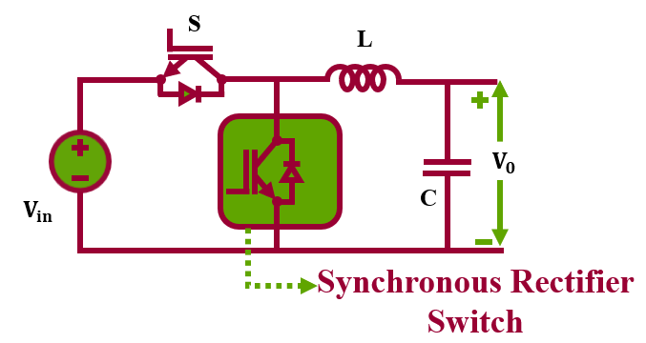
Figure 5: Synchronous Rectifier
The on and off switches of the MOSFET are synchronized with the conduction of the diode. It provides lower voltage drops and conduction losses than traditional diodes.

3.5 Isolation Transformer
Isolation transformers are commonly used in onboard chargers and DC-DC converters to ensure safety and protect the vehicle's power electronics and battery from electrical faults. It provides electrical isolation between the AC input and the DC output. When transmitting electrical power from an AC power supply to specific devices or equipment, an isolation transformer is utilized to separate the enabled device from the power source. The isolation transformer is displayed in Figure 6.
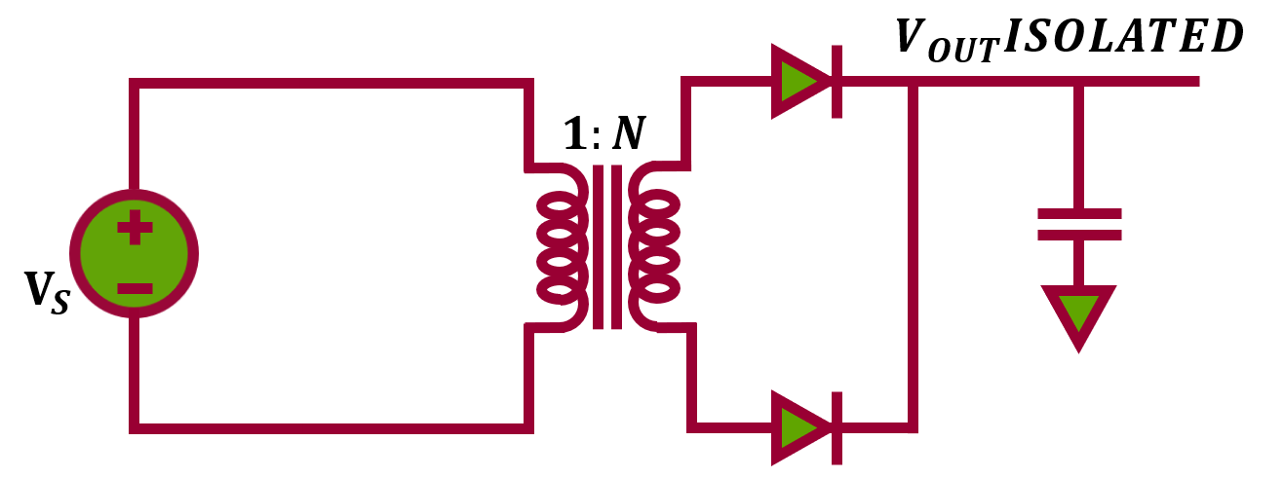
Figure 6: Isolation Transformer
Its primary and secondary coil circuits are electrically isolated to an isolation transformer. By keeping the equipment electrically isolated from the power source, this design enables the safe transmission of electrical power from an AC source to devices or equipment. The main uses of this isolation are safety or to lessen electrical transients and harmonics. Additionally, it is a technique that uses an incredibly accurate adjustment mechanism to transmit electrical energy to a load. It is frequently used to control a variety of applications, including electric motor speed, lighting intensity, and ultrasonic cleaning processes. Moreover, an isolation transformer is used on the input or output side for safety reasons and voltage level adaptation generally.

4. Results and Discussion
The proposed an efficient high-frequency inverter based on the WPT system is implemented for the EV system using MATLAB Simulink software. These simulation results reveal the characteristics of voltage and current in input voltages of 230V and 220V. Further, results demonstrate this work is improving EV charging efficiency, optimizing the overall system’s performance.
Voltage 230
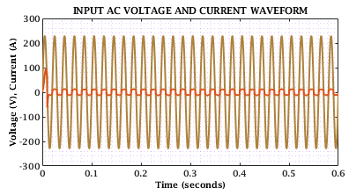
Figure 7: Input AC voltage and current waveform
Figure 7: demonstrates the input AC voltage and the current waveform at an input voltage of 230V. The waveforms are combined and travel together in 0 to 1 seconds. Further, the voltage range is 200V to -200V, and the current range is 100A to 0A.
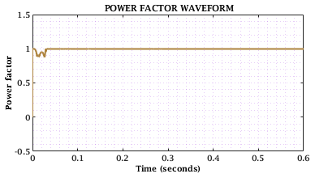
Figure 8: Power factor waveform
The power factor waveform at an input voltage of 230V is shown in Figure 8. The power factor of 1 is initially obtained, and after 0.03 seconds, the power factor is decreased and then maintained at a constant factor of 1.
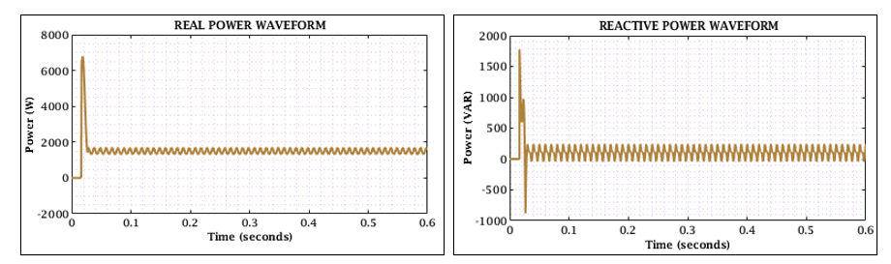
Figure 9: Real and Reactive power waveform

The real and reactive power waveforms at an input voltage of 230V are shown in Figure 9. In real power, after a rapid initial increase to 6900 W, the current slowly drops after 0.03 seconds. This current drops to 1800 W after 0.1 seconds, at which point it starts to oscillate in speed. In reactive power at an input power supply of 230V, the waveforms achieve 1800 VAR in 0.02 seconds.

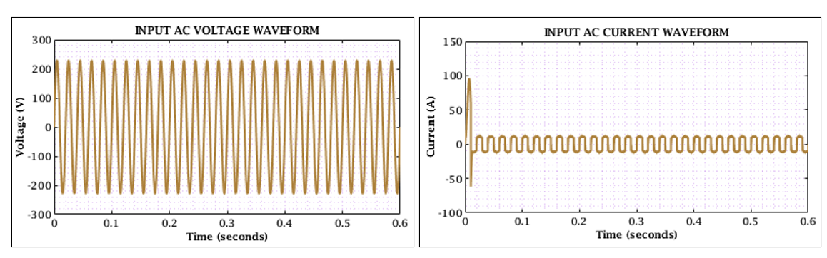
Figure 10: Input AC voltage and current waveform

Figure 10: demonstrates the input AC voltage and the current waveform at an input voltage of 230V. The voltage range is 250V to -250V in 0 to 0.6 seconds, and the current range is achieving a maximum value of 100A and down to -65A in 0 to 0.6 seconds.
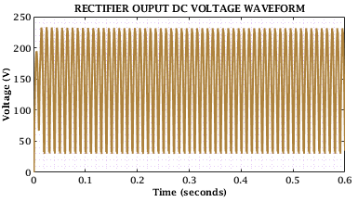
Figure 11: Rectifier output DC voltage waveform
Figure: 11 displays the rectifier output DC voltage waveform at an input voltage of 230V. The voltage rises quickly in the beginning in 0 seconds. After 0.01 seconds, the sinusoidal waveforms are achieved, with a current range that varies between 230 V and 30 V.
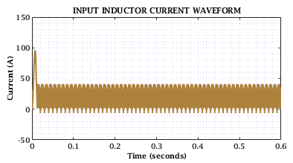
Figure 12: Input inductor waveform
Figure 12: indicates the input inductor waveform at an input voltage of 230V. In the first 0 seconds, the voltage increases rapidly. This current reaches its maximum of 99 A after 0.01 seconds, at which point it proceeds to oscillate continuously.

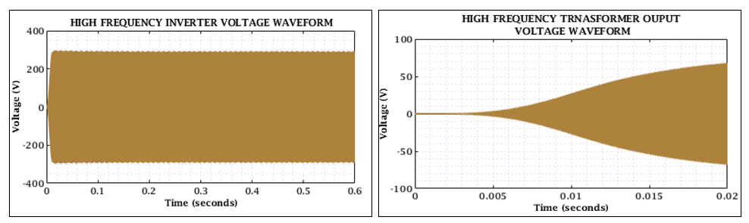
Figure 13: Voltage waveforms of high frequency inverter and transformer

Figure 13: shows that the voltage waveforms of the high-frequency inverter and transformer are at an input voltage of 230V. In the first plot, the voltage occupied the range between 300V and -300V, and it greatly contributes to improving power quality. In the second plot, initially, the 0 voltage is manually increased in the range between 70V and -70V in 0 to 0.02 seconds.

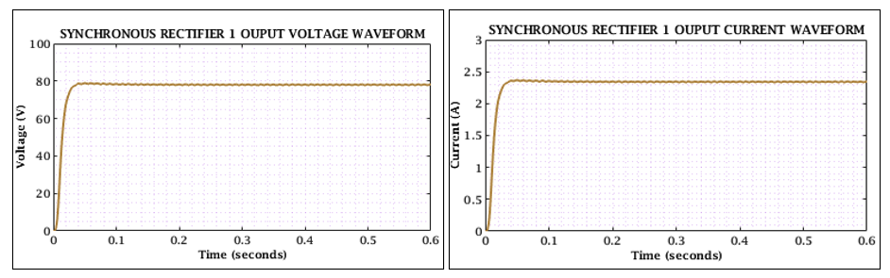
(a)
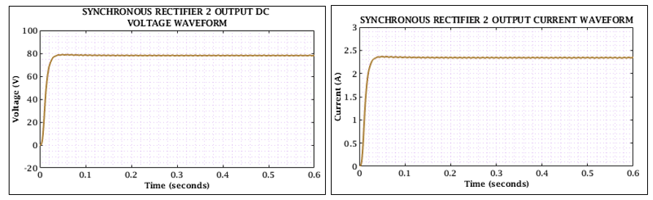
(b)
Figure 14: Output DC voltage and current waveforms of synchronous rectifiers 1 (a) and 2 (b)

The output DC voltage and current waveform of synchronous rectifier 1 (a) and 2 (b) at an input voltage of 230V is presented in Figure 14. Initially, the voltage is manually increased up to 80V, and then the voltage is produced so the waveform oscillates in 0 to 0.06 seconds. The current is manually increased up to 2.4 A, and it produced a waveform oscillating in 0 to 0.6 seconds.
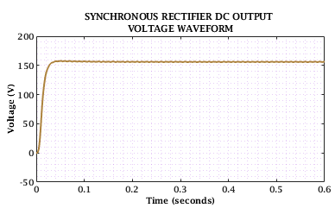
Figure 15: Synchronous rectifier output DC voltage waveform
The synchronous rectifier output DC voltage waveform at an input voltage of 230V is presented in Figure 15. Initially, the voltage is manually increased up to 160V, and then the voltage is produced so the waveform oscillates in 0 to 0.06 seconds.
Voltage 220
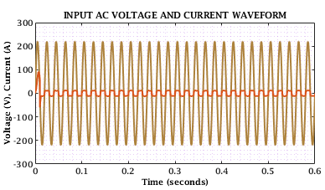
Figure 16: Input AC voltage and the current waveform
Figure 16: demonstrates the input AC voltage and the current waveform at an input voltage of 220V. The waveforms are combined and travel together in 0 to 1 seconds. Further, the voltage range is 200V to -200V, and the current range is 100A to 0A.
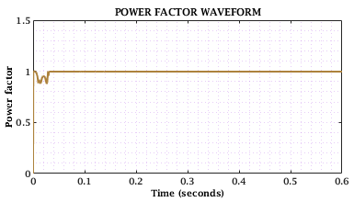
Figure 17: Power factor waveform
Figure 17: displays the power factor waveform with a 220V input voltage. First, a power factor of 1 is achieved; after 0.03 seconds, the power factor is reduced and then kept at a constant 1.

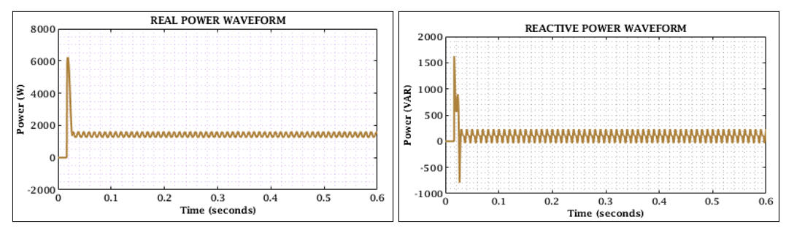
Figure 18: Real and reactive power waveforms

Figure 18: displays the real and reactive power waveforms with a 220V input voltage. In real power, the current increases quickly at first, reaching 6900 W, and then gradually decreases after 0.03 seconds. After 0.1 seconds, this current lowers to 1800 W and begins to fluctuate in speed. Similarly, in reactive power, the waveforms reach 1600 VAR in 0.02 seconds at a 220V input power supply.

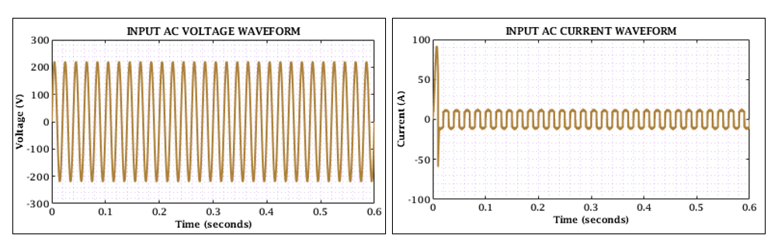
Figure 19: Input AC voltage and current waveform

The input AC voltage and current waveform at a 220V input voltage are shown in Figure 19. In 0–0.6 seconds, the voltage ranges from 210V to -210V, and in 0 to 0.6 seconds, the current ranges from a maximum of 100A to -65A.
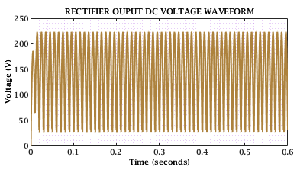
Figure 20: Rectifier output DC voltage waveform
The rectifier output DC voltage waveform at a 220V input voltage is shown in Figure 20. In the first 0 seconds, the voltage increases rapidly. The sinusoidal waveforms, with a current range of 225 V to 35 V, are obtained after 0.01 seconds.
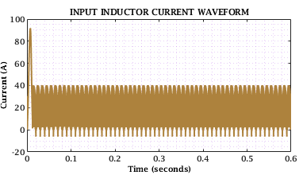
Figure 21: Input inductor waveform
The input of the inductor waveform at a 220V input voltage is shown in Figure 21. The current rises quickly in the first 0 seconds. Following 0.01 seconds, this current reaches its maximum of 95 A, then drops down to 40 A and flows the current range between 40 A to -10 A, which it begins to oscillate continually.

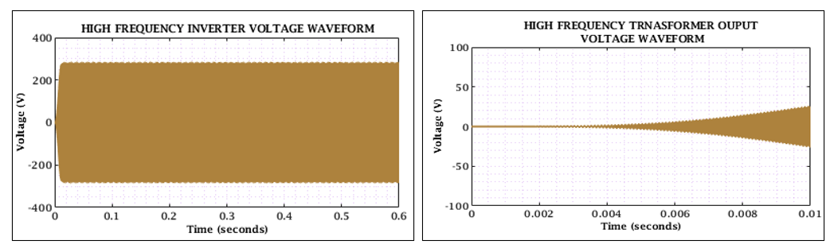
Figure 22: The voltage waveforms of high frequency inverter and transformer

The voltage waveforms of the high-frequency inverter and transformer at 220V input voltage are displayed in Figure 22. In the first graph, the voltage significantly improves power quality, taking up the region between 280V and -280V in the plot. The second graph illustrates that the voltage, in a time span of 0 to 0.01 seconds, the 0 voltage is manually raised between 25V and -25V.

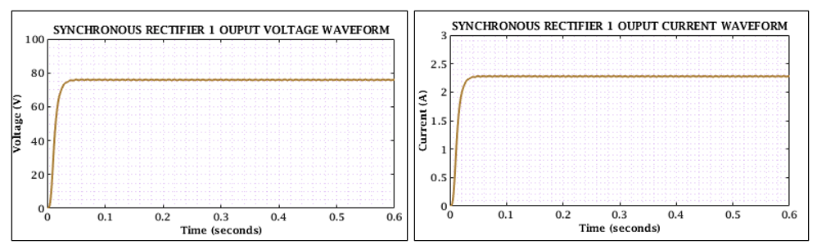
(a)
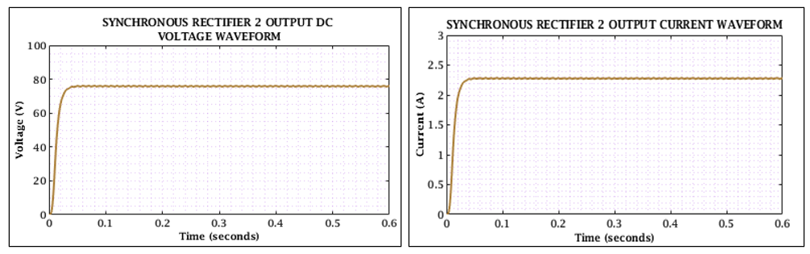
(b)
Figure 23: Output DC voltage and current waveforms of synchronous rectifiers 1 (a) and 2 (b).

Figure 23: shows the DC voltage and current waveforms of synchronous rectifiers 1 (a) and 2 (b) at a 220V input voltage. The voltage is generated so that the waveform oscillates for 0 to 0.06 seconds after it has first been manually raised to 75V. When the current is manually raised to 2.3 A, a waveform oscillating for 0 to 0.6 seconds is created.
Figure 24: shows the DC voltage waveform of the synchronous rectifier's output at a 220V input voltage. The voltage is first manually raised to 150V, after which it is generated to cause the waveform to oscillate for 0 to 0.6 seconds.
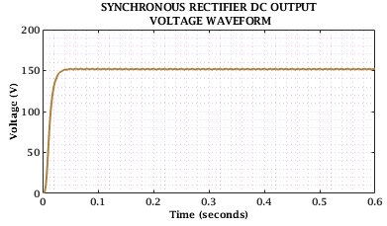
Figure 24: Synchronous rectifier DC output voltage waveform
Table 1: Performance of Comparative Analysis
Inverters | Efficiency
Multisource Inverters [14] | 0.87
Single Phase Invertor [11] | 0.94
Multilevel Invertor [12] | 0.95
Proposed 1 $∅$ High-Frequency Inverter | 1
The results of the comparison analysis between the proposed and different investors are shown in Table 1. The proposed single phase high-frequency inverter attains a power factor value of 1 in comparison to alternative power factor-based approaches.
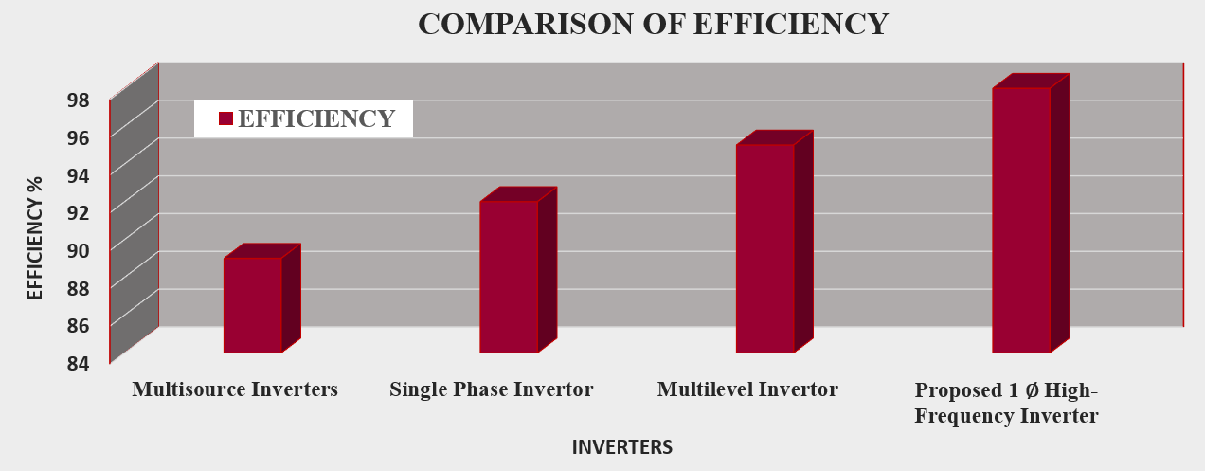
Figure 25: Comparison of Efficiency
A performance comparison is shown in Figure 25. Based on efficiency, the proposed inverter and an alternative inverter, such as the multilevel inverter [12] of 95%, the single-phase inverter [11] of 92%, and the multisource inverters [14] of 89%, have been highlighted. When compared to the other inverters, the proposed inverter has the maximum efficiency of 98% achieved.

5. Conclusion
An efficient high-frequency resonant inverter based on WPT is proposed in this work for the EV charging system. Interleaved synchronous rectifier reduces losses during power conversion and maximizes the range and overall performance. Further, isolation transformers ensure safety and protect the vehicle's power electronics and battery from electrical faults. High-frequency inverters operate at higher switching frequencies compared to traditional inverters, which typically operate at lower frequencies. Finally, this work is providing the proper, efficient power supply for EV charging applications. It offers highlights of the efficacy of 98% achieved, and it analyzes previous techniques. Finally, it demonstrates the high-frequency resonant inverter is suitable for the EV charging system.

Reference
1. Bhim Singh, Anjeet Verma, Ambrish Chandra, Kamal Al-Haddad, 2020, “Implementation of Solar PV-Battery and Diesel Generator Based Electric Vehicle Charging Station”, in IEEE Transactions on Industry Applications, Vol: 56, No: 4, pp. 4007-4016.
2. Mahmoud N.Ali, Karar Mahmoud, Matti Lehtonen, Mohamed MF Darwish, 2021, “An Efficient Fuzzy-Logic Based Variable-Step Incremental Conductance MPPT Method for Grid-Connected PV Systems”, in IEEE Access, Vol. 9, pp. 26420-26430.
3. Yingying hao, Aimin An, Yifan Xu, Qianqian Wang, Minmin Wang, 2021, “Model Predictive Control of Grid-Connected PV Power Generation System Considering Optimal MPPT Control of PV Modules”, in Protection and Control of Modern Power Systems, Vol: 6, No: 4, pp. 1-12.
4. Nabil A.Ahmed, Bader N. Alajmi, Ibrahim Abdelsalam, Mostafa I. Marei, 2022, “Soft Switching Multiphase Interleaved Boost Converter with High Voltage Gain for EV Applications”, in IEEE Access, Vol: 10, pp. 27698-27716.
5. Mohammad Haziq Ibrahim, Swee Peng Ang, Muhammad Norfauzi Dani, Mohammad Ishlah Rahman, Rafidah Petra, Sheik Mohammed Sulthan, 2023, “Optimizing Step-Size of Perturb & Observe and Incremental Conductance MPPT Techniques Using PSO for Grid-Tied PV System”, in IEEE Access, Vol: 11, pp. 13079-13090.
6. Thamatapu Eswara Rao, Elango Sundaram, Sharmeela Chenniappan, Dhafer Almakhles, Umashankar Subramaniam, Mahajan Sagar Bhaskar, 2022, “Performance Improvement of Grid Interfaced Hybrid System Using Distributed Power Flow Controller Optimization Techniques”, in IEEE Access, Vol: 10, pp. 12742-12752.
7. Shi-Zhou Xu, Yi-Ming Zhong, 2024, “NSNPSO-INC: A Simplified Particle Swarm Optimization Algorithm for Photovoltaic MPPT Combining Natural Selection and Conductivity Incremental Approach”, in IEEE Access, Vol: 12, pp. 137760-137774.
8. Binxin Zhu, Guanghui Liu, Yao Zhang, Yu Huang, Shishi Hu, 2021, “Single-Switch High Step-Up Zeta Converter Based on Coat Circuit”, in IEEE Access, Vol: 9, pp. 5166-5176.
9. Ghazi A. Ghazi, Essam A. Al-Ammar, Hany M. Hasanien, Wonsuk Ko, Jaesung Park, Dongsu Kim, Zia Ullah, 2024, “Dandelion Optimizer-Based Reinforcement Learning Techniques for MPPT of Grid- Connected Photovoltaic Systems”, in IEEE Access, Vol: 12, pp. 42932-42948.
10. Ying He, Liang Chen, and Xuanjin Sun, 2024, “An Interleaved Buck-Boost-Zeta Converter with Coupled Inductor Multiplier Cell and Zero Input Current Ripple for High Step-Up Applications”, in IEEE Access, Vol: 12, pp. 104807-104817.
11. Allamsetty Hema Chander, K. Dhananjay Rao, Bankupalli Phani Teja, Lalit Kumar Sahu, Subhojit Dawn, Faisal Alsaif, Sager Alsulamy, Taha Selim Ustun, 2023, “A transformerless photovoltaic inverter with dedicated MPPT for grid application”, IEEE Access, Vol: 11, pp. 61358–61367.
12. Debabrata Mazumdar, Pabitra Kumar Biswas, Chiranjit Sain, Taha Selim Ustun, 2024, “GAO Optimized Sliding Mode Based Reconfigurable Step Size Pb&O MPPT Controller with Grid Integrated EV Charging Station”, in IEEE Access, Vol: 12, pp. 10608-10620.
13. Xupeng Fang, Xuewen Lai, Xuchao Wang, Hang Zhao, 2024, “The High Voltage Gain Coupled Inductor Boost-Zeta DC/DC Converter”, in CPSS Transactions on Power Electronics and Applications, Vol: 9, No: 2, pp. 127-140.
14. Mohammad Ali Hosseinzadeh, Maryam Sarebanzadeh, Cristian F. Garcia, Ebrahim Babaei, Jose Rodriguez, Ralph Kennel, 2024, “A New Generalized Multisource Inverter for Electric Vehicles Controlled by Model Predictive”, in IEEE Transactions on Industrial Electronics, Vol: 71, No: 9, pp. 10184-10197.
15. Erdem Gümrükcü, Ehsan Asadollahi, Charukeshi Joglekar, Ferdinanda Ponci, Antonello Monti, Giuseppe Guidi, Salvatore D’Arco, Jon Are Suul, 2022, “Optimal Management for Megawatt Level Electric Vehicle Charging Stations with a Grid Interface Based on Modular Multilevel Converter ”, in IEEE Access, Vol: 10, pp. 258-270.

